**Process & Tools Wiki**

**Purpose**

The purpose of this page is to document our iterative process for building the prototype and provide evidence via images, links, and other supporting documentation.

**Evidence & Artifacts**

**Attachment E: Criteria # 11 - Iterative, Agile Process**

**Ceremonies**

Though we practiced continuous delivery deploying code multiple times per day, we used the scrum ceremonies to enable team collaboration and feedback loops. We developed the prototype following a 5-sprint cycle, with 24 hour sprints which included daily stand ups, backlog grooming, sprint demos, and user interviews. We also facilitated a mid-codeathon retrospective.

Below we highlight our calendar of ceremonies as evidence on our agile, iterative approach: 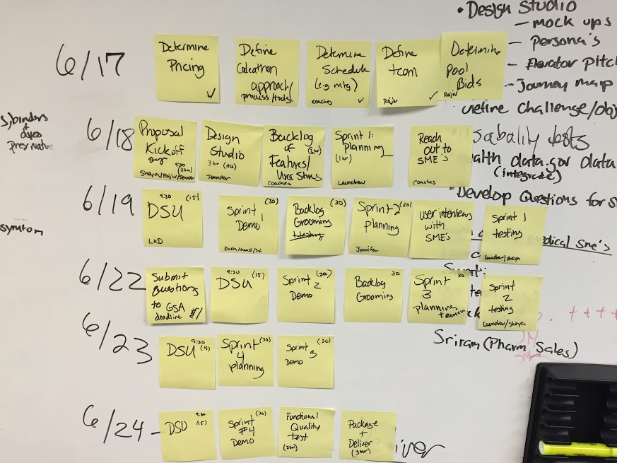

Figure 1 - Iterative Calendar

**Retrospective**

Below is the output from our mid-codeathon retrospective, where we identified potential improvements and identified actions, which each have an owner and were entered into our backlog. 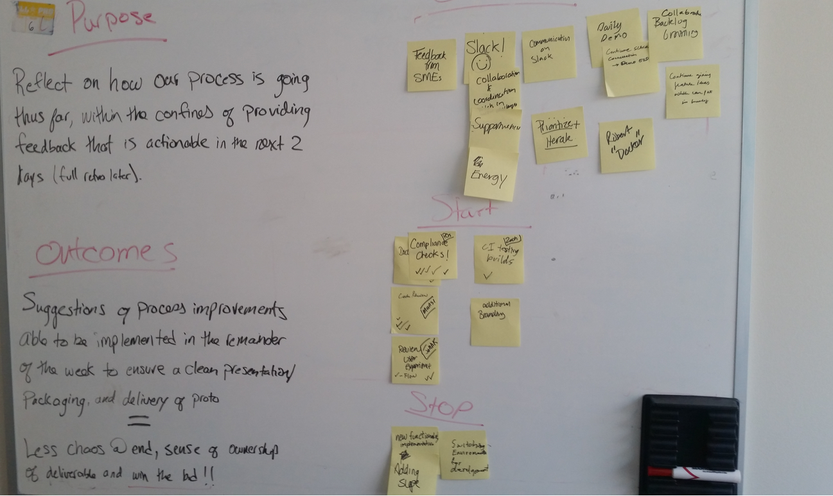

Figure 2 Retrospective

**Our Agile Journey**

Below is a recap of each of our sprints:

**Sprint 0**

The primary focus of Sprint 0 was to set up infrastructure in AWS for the prototype, and set up a basic search page to access the OpenFDA dataset API. We also defined our initial MVP during this sprint through user research and engagement.

**Sprint 1**

The primary focus of Sprint 1 was to enhance the faceted search feature and continue infrastructure setup.

**Sprint 2**

The primary focus of Sprint 2 was to continue iterating based on feedback from users including feature enhancements to the search capability and add the adverse event dataset, including exploratory analysis.

**Sprint 3**

The primary focus of Sprint 3 was to close out feature development for the prototype related to the datasets, including adding in the Recall dataset, and to continue work on the infrastructure enhancements.

**Sprint 4**

The primary focus of Sprint 4 was to improve UI, address major bug fixes, and infrastructure enhancements based on user feedback.

**Sprint 5**

The primary focus of Sprint 5 was to continue bug fixes, UI features, and infrastructure enhancements, as well as to finalize all documentation.

**Sprint 6**

The goal of Sprint 6 was to deliver the prototype and all supporting documentation.

**Product Backlog**

The Product Backlog contains all features, enhancements, technical spikes, and data integrity issues we were unable to incorporate into our prototype due to the effort required; however, we would like all items to be considered for future development--either by team eGT or others.

**Tools**

We also used a variety of collaboration and information radiators, to support our continuous delivery including:

**GitHub:**

Not only did we use GitHub as the final repository to ship the prototype and related requirements, but also to store the backlog of features, bugs, technical spikes, and technical debt.

The Product Manager prioritized the features after the grooming sessions and demos by moving the issues from the Product Backlog milestone to an appropriate sprint milestone and tagging them with a priority level as necessary.

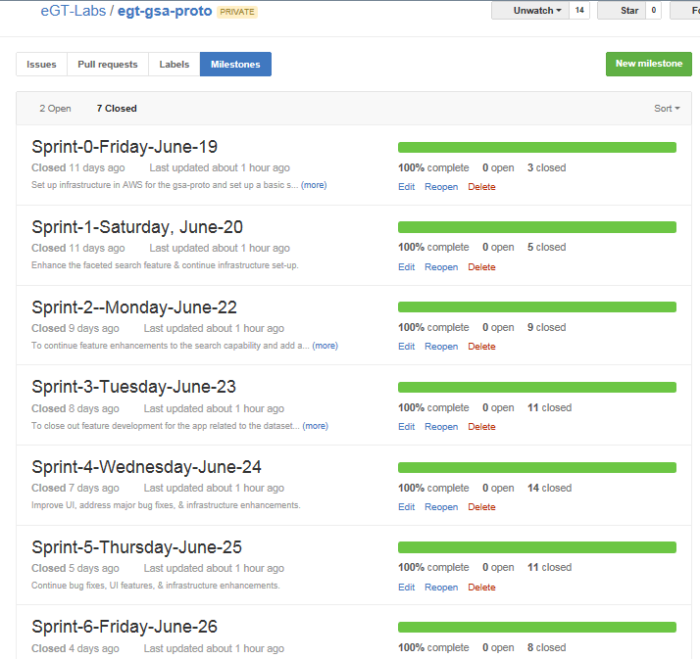

Figure 3 - Backlog Snapshot

For additional evidence on our iterative, agile approach including our Product Backlog see our MVP folder in our repository located here:

egt-gsa-proto/docs/MVP/18f-GSA-eGlobaltech-Product-Backlog.docx

**Slack:** The team created various channels within slack to ask questions, share links and articles, troubleshoot issues, and to post images of mock-ups and/or feature acceptance criteria for feedback before entering them as stories into GitHub. 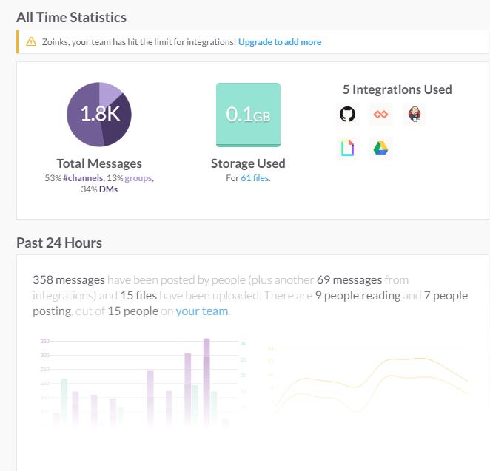

Figure 4 Slack

**Google Docs:**We used Google Docs to collaborate on working documentation for the prototype effort, such as questions to GSA, recommendations for fulfilling and providing evidence for Pool 2 requirements, and the team challenge statement and MVPs.

**JoinMe:**Offsite team members utilized JoinMe during Sprint demos.